Report

**Analysing Housing Prices In Metropolitan Areas Of India**

1. Introduction;
   1. **Overview;**

The topic concerns the analysis of housing prices in metropolitan areas of India with a focus on developing a predictive model for estimating house prices. This model utilizes historical sales data, property details, and location-specific information to provide accurate price predictions. The primary aim is to offer a valuable solution for potential home buyers, real estate agents, and investors operating in the dynamic real estate market of Indian metropolitan cities.

* 1. **Purpose;**

Price Prediction: The main purpose is to develop a predictive model that can accurately estimate house prices. This helps potential buyers make informed decisions about property purchases and aids real estate agents and investors in pricing properties competitively.

Empowering Stakeholders: The goal is to provide reliable insights and data-driven predictions, enabling stakeholders to navigate the complex and fast-paced real estate market with confidence.

User-Friendly Interface: The model is designed with a user-friendly interface, making it accessible and usable for a wide range of users, including those with limited technical expertise.

Scalability and Real-Time Updates: The model is expected to be scalable, allowing it to handle a large volume of data and deliver real-time updates, keeping users informed about market fluctuations.

Transparency: Transparency in data sources, modeling techniques, and pricing factors is essential to build trust among users, ensuring they understand how predictions are generated.

1. Problem Statement & Design thinking;
   1. Empathy map;

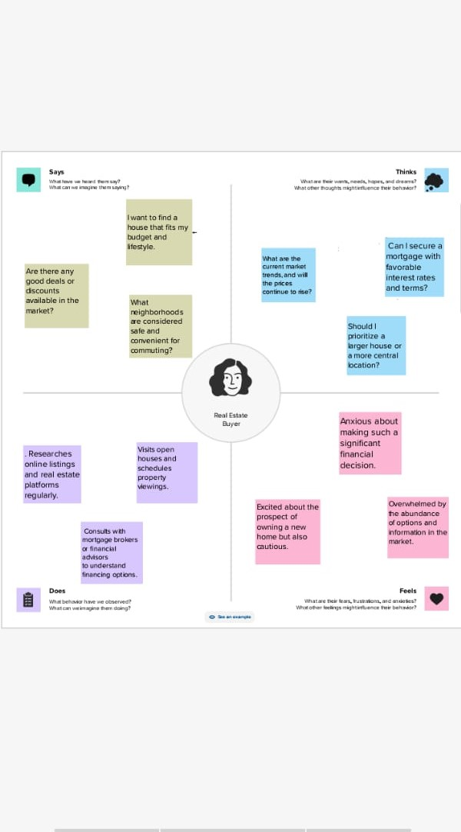

* 1. Brain stroming:



1. Result:
   1. Dashboard:

 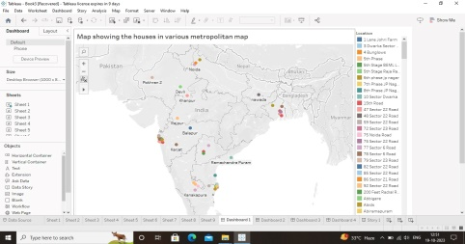

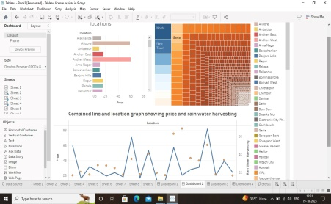

* 1. Story:

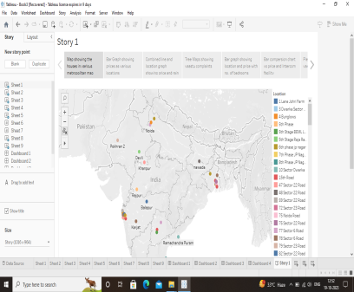

1. Advantages and Disadvantages:
   1. Advantages:

Informed Decision-Making: Potential home buyers, real estate agents, and investors can make well-informed decisions by relying on accurate price predictions, leading to better investment outcomes.

Market Competitiveness: Real estate agents can set competitive prices for properties, and buyers can identify favorable deals, contributing to a more competitive and efficient housing market.

User-Friendly: The user-friendly interface ensures that a wide range of users can easily access and benefit from the predictive model, regardless of their technical expertise.

Scalability and Real-Time Updates: The scalability and real-time updates allow the model to adapt to changing market conditions, ensuring users have access to the most up-to-date information.

Transparency: The transparent approach enhances trust and confidence in the model's predictions, as users can understand the rationale behind the price estimates.

* 1. Disadvantages:

Data Privacy Concerns: Handling sensitive data such as property details and historical sales data raises concerns about data privacy and security. Ensuring data protection and compliance with regulations is critical.

Cost of Implementation: Developing and maintaining such predictive models can be costly, including data acquisition, model development, and infrastructure costs. The expenses may limit accessibility.

Data Quality: The accuracy of predictions is highly dependent on the quality of historical data, which may be incomplete or inaccurate in some cases.

Market Volatility: Real estate markets can be highly volatile, making it challenging to develop a model that accurately accounts for rapid price fluctuations.

Variable Factors: Predicting housing prices involves numerous factors, such as economic conditions, government policies, and local infrastructure development, making it complex to capture all relevant variables in the model.

1. Applications:

Real Estate Investment: Investors can use the predictive model to identify lucrative investment opportunities and make data-driven decisions regarding buying and selling properties.

Property Valuation: Real estate agents can accurately determine the market value of properties, which helps in setting competitive prices and negotiating with clients.

Home Buying: Potential home buyers can use the model to understand whether a property is priced fairly, helping them avoid overpaying or missing out on good deals.

Market Research: Researchers and analysts can use the data generated by the model for in-depth market research, tracking trends, and gaining insights into the real estate market's dynamics.

Urban Planning: City planners and local governments can benefit from the data to make informed decisions about infrastructure development and zoning regulations, ensuring sustainable growth.

1. Future Scope:

AI Advancements: As artificial intelligence and machine learning continue to advance, predictive models can become even more accurate and sophisticated, incorporating a broader range of data sources.

Smart Cities: The development of smart cities in India may lead to increased demand for such predictive models to manage housing and infrastructure development efficiently.

Data Integration: Future developments could involve integrating more data sources, such as social and economic factors, to provide a more comprehensive understanding of property values.

Affordable Housing: Predictive models can play a vital role in addressing the challenge of affordable housing by helping identify areas where housing prices are within reach for a larger section of the population.

Policy Development: Policymakers can use insights from such models to formulate housing and urban development policies that are in line with market realities.

1. Conclusion:

Analyzing housing prices in Indian metropolitan areas and developing predictive models is a valuable endeavor with far-reaching benefits. It empowers various stakeholders, including home buyers, real estate agents, and investors, by providing accurate, data-driven insights into the housing market. The future scope for such models is promising, especially with advancements in AI and the growing importance of urban planning and development.

However, it's important to address challenges related to data privacy, data quality, and market volatility. Ensuring transparency in the model's methodology and adhering to cost-effective solutions will be crucial for long-term success. As India's real estate market continues to evolve, these predictive models will remain a valuable tool for individuals and organizations involved in the property market, contributing to more informed and efficient decision-making.

Top of Form